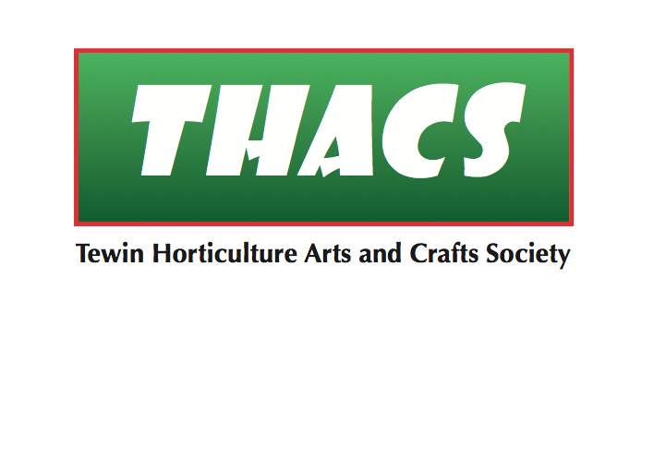

**Spring Show Saturday 9th April 2022**

Prizes and Awards

***Adult classes:*** First place Certificate

Second & third place Rosettes

###### *Children’s classes:* Various certificates and prizes

**Trophies**

Welwyn Times Trophy for Flower Arranging

Van Hage Cup for Horticulture

Marian Meads Memorial Trophy for Arts & Crafts

Peter Allen Cup for Photography

Nodder Bowl for Culinary

Tewin Cowper School Award for Children

Les Borg Cup for Children’s Photography

**Judges**

|  |  |
| --- | --- |
| *Flower Arranging* | **Joyce Furssedonn** |
| *Horticulture* | **Joyce Furssedonn** |
| *Art* | **Jude O’Sullivan** |
| *Handicrafts* | **Anne Styles** |
| *Poetry & Prose (adult)* | **Frances Wilson** |
| *Poetry & Prose (children)* | **Joanne Allen** |
| *Photography* | **Byron Sinfield** |
| *Culinary* | **Sue Crawley** |



*THACS* is affiliated to the

Royal Horticultural Society